SIMATS ENGINEERING
ASSESSMENT TOOL 2
Case study

COURSE NAME: OBJECT ORIENTED ANALYSIS AND DESIGN
COURSE CODE: CSA11

COURSE OUTCOME COVERED

CO3: Analyze system requirements using object-oriented techniques to identify classes, attributes, and relationships and develop use case models. (BL4)

Assessment Tool Weightage: 40%

Code of Conduct:

I Nithishkumaran M 192320037(Name / Reg No) certify that this submission is my original work and that I have adhered to the guidelines specified for this assessment.
I understand that any violation of academic integrity rules will result in disciplinary action.

Signature of the student:
Nithishkumaran M

4.Smart Renewable Energy Monitoring System (SDG 7: Affordable and Clean Energy)
A smart city uses solar panels and wind turbines to generate electricity. Energy sensors monitor power generation, battery storage, and energy consumption. Consumers can monitor their electricity usage through a mobile application. Maintenance engineers receive alerts whenever equipment failures occur. The administrator generates monthly energy production reports and manages renewable energy resources.

Analyze the system and perform the following:
- Draw the Use Case Diagram.
- Identify all major classes and attributes and draw the Class Diagram.
- Show suitable relationships among the classes using UML notations

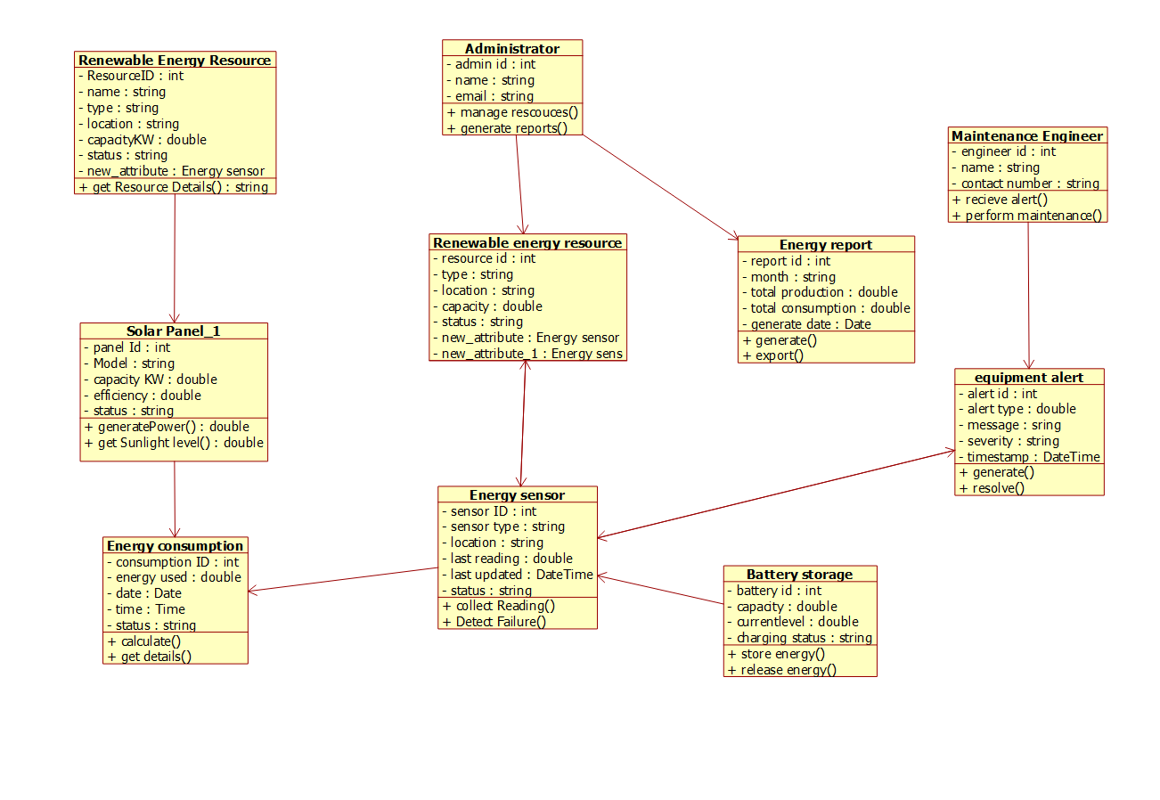

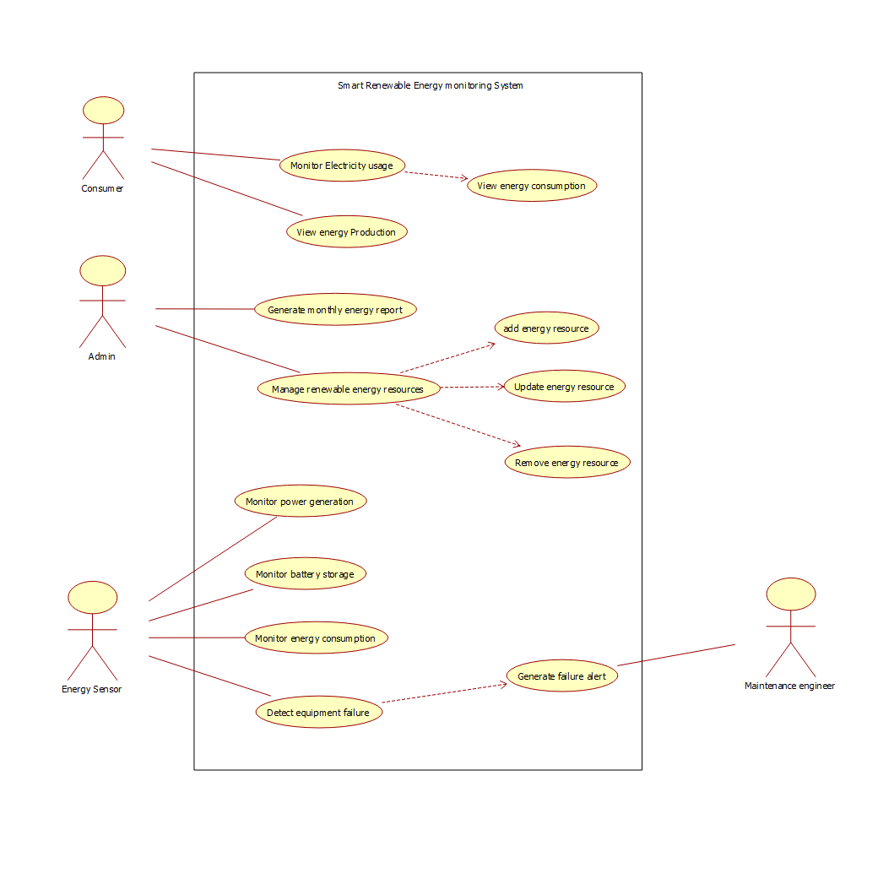

RUBRICS FOR CALCULATION:

Case study

Criteria | Weightage | Level 4 – Exemplary | Level 3 – Proficient | Level 2 – Developing | Level 1 – Beginning
Understanding of Case | 25 | Thorough understanding; clearly identifies all key issues | Good understanding with most issues identified | Basic understanding; some issues missed | Poor understanding; problem not identified correctly
Application of Concepts | 25 | Effectively applies relevant concepts to analyze the case deeply | Applies appropriate concepts with minor gaps | Limited application of concepts | Fails to apply relevant concepts
Analysis | 20 | In-depth analysis with strong reasoning and insights | Good analysis with logical reasoning | Basic analysis with limited depth | Weak or no analysis; lacks reasoning
Solution Design | 20 | Innovative, feasible solutions with strong justification | Logical solutions with adequate justification | Basic solutions with weak justification | Incorrect or no solution provided
Clarity | 10 | Clear, well-structured, and easy to understand | Organized and understandable presentation | Limited clarity and structure | Poor clarity; difficult to understand

